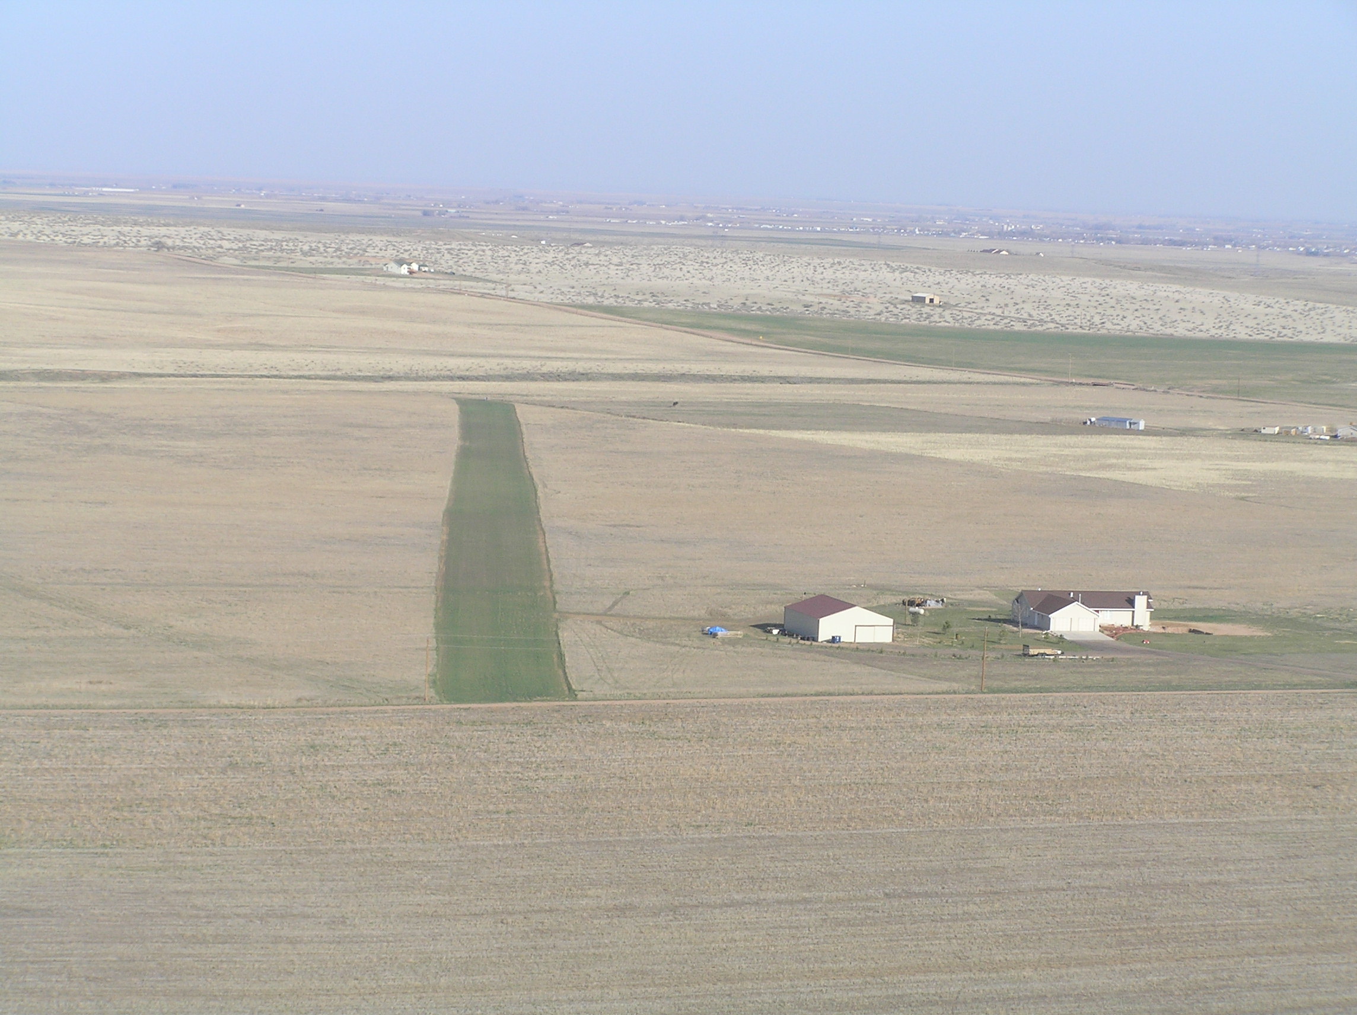

FIRST ANNUAL MEMORIAL DAY FLY-IN

DATE: May 25th, 2009
TIME: 0630-1000
LOCATION: 1CD1 Reed Field (104.52.06W, 40.41.43 N)
Field Elevation: 5350’
CTAF: 122.85
Preferred Landing to the NW, Takeoff SE

WE PROVIDE: Coffee, Water, Juice, Pancakes, and Sausage provided

You Bring: Tie Downs
Plates and utensils
Cups/mugs
chairs

Kids and Families welcome

RSVP: 970-897-3066, rreed@fcgov.com, 4reed@what-wire.com with numbers attending so we can have enough food.

If you have not flown into Reed Field before there are power lines at the end of the runway at the northwest end, and the runway slopes uphill SE to NW.

Cancellation will be made by 2000 hours on May 24th, due to weather. If you send your RSVP by email, I will cancel by emails by 2000 on May 24th.

Hope to see you here.

Russ

